**Daily Scrum or Standup Meeting**

Team name: ______TEAM 4___________________

Scrum Master: ______ Brock Francom_________

Date:___________11/15/19____________________

|  |  |  |  |
| --- | --- | --- | --- |
| **Team Member** | **What did you do since the last scrum?** | **What do you plan to do before the next scrum?** | **What obstacles do you have?** |
| Carter Figgins | Not much ☹ | Learn all I can about unit test and write a practice test. | Learning unit testing for django |
| Brock Francom | Fixed some bugs | Start unit tests for views | Uint tests |
| Waseca Hodson | Researched unit testing, started implementing a random model seeder to fill the testing model. | Continue implementing unit tests. | Unit tests |
| Sterling Tolley | Fixed bugs and resolved some issues with updating item prices. Finished revising the site with bootstrap | Implement user password changing |  |
|  |  |  |  |

# Burndown

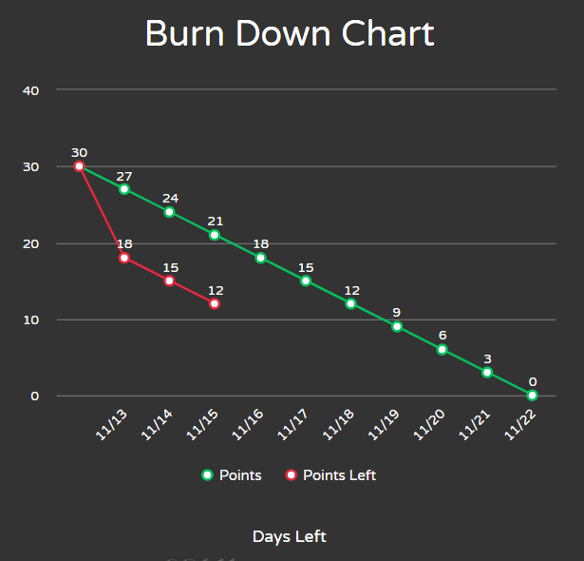

# Screenshot of you project board

